Simple Rules Engine

Installation Guide

Version: 1.2
Revision Date: July 21, 2008

Table of Contents
1 Accessing the Simple Rules Engine 3
2 Software Pre-requisites 4
3 Installing the engine 5
4 Adding system messages 11
5 Adding repository configuration 12
6 Setup the Web Service 13
7 Need more information? 16

Accessing the Simple Rules Engine
The ext.IT Simple Rules Engine (SRE) can be accessed as an ASP.Net web service, or using the Onyx Enterprise Application Server adapter (for Onyx customers). Before continuing with the SRE setup, decide which access method will be used for the installation.
Note: it is possible to use both access methods on the same server, and if there is any conflict in this case between settings for the Onyx and web service settings, the Onyx settings should be used.

Software Pre-requisites
The following software must be installed before installing the SRE:
- Microsoft .Net Framework 2.0
- Onyx Enterprise Application Server v5.x or v6.0 (for use with the Onyx SRE adapter).

Installing the engine
The SRE engine runs as a Windows COM+ application. This section details the steps required to install and configure the engine to run correctly.
- Unzip the installation package contents to a suitable location to run the SRE from (eg. “c:\Program Files\ext.IT Simple Rules Engine”). This location will be referred to as the installation location and <install location> throughout this document.
- Go to the folder: <install location>\engine\runtime\release.
- Run the RegisterComponent.bat batch file. A command window will be displayed with the progress and should not include any error messages.
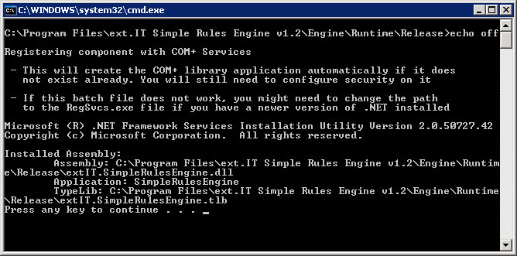
- Open the Windows Component Services administration tool, and browse to the SimpleRulesEngine COM+ application.
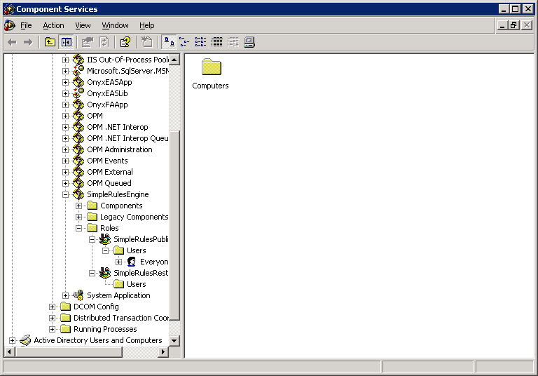
- Open the Properties dialog for the SimpleRulesEngine application.
- In the Advanced tab, ensure that the "Leave Running when idle" option is selected from the Server Process Shutdown radio button group.
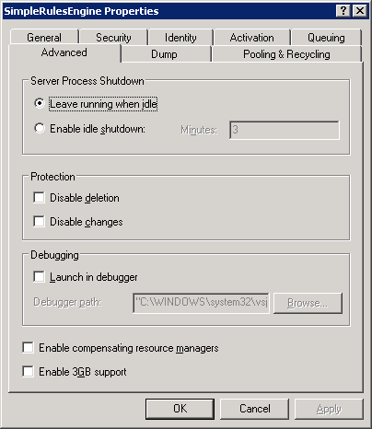
- In the Activation tab, set the Application Root Directory to the folder: <install location>\engine\runtime\release.
- Set the identity for the COM+ application.
When using the Onyx SRE adapter:
In the Identity tab, change the application to run as the OnyxEASUser local or domain user that is used to run the OnyxEASApp COM+ application.
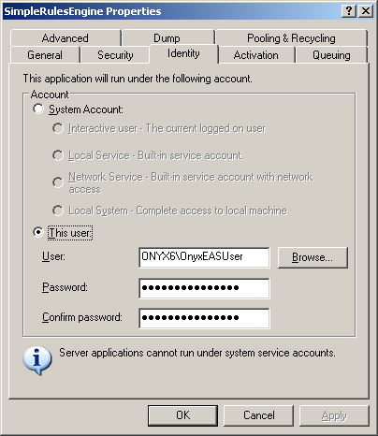
When using the web services SRE interface:
In the Identity tab, change the application to run as the local service account.
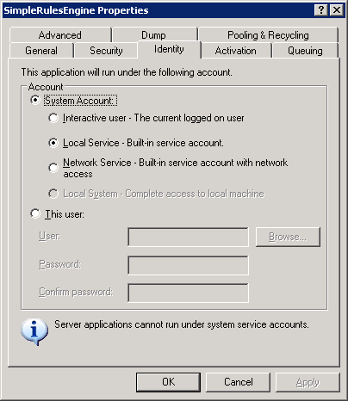
- Save the changes to the COM+ application by clicking OK to close the properties dialog.
- In the Roles for the SimpleRulesEngine COM+ application, add the Everyone group to the SimpleRulesPublic role.
- When using the Onyx SRE adapter, in the Roles for the SimpleRulesEngine COM+ application, add the OnyxEASUser local or domain user to the SimpleRulesRestricted role.
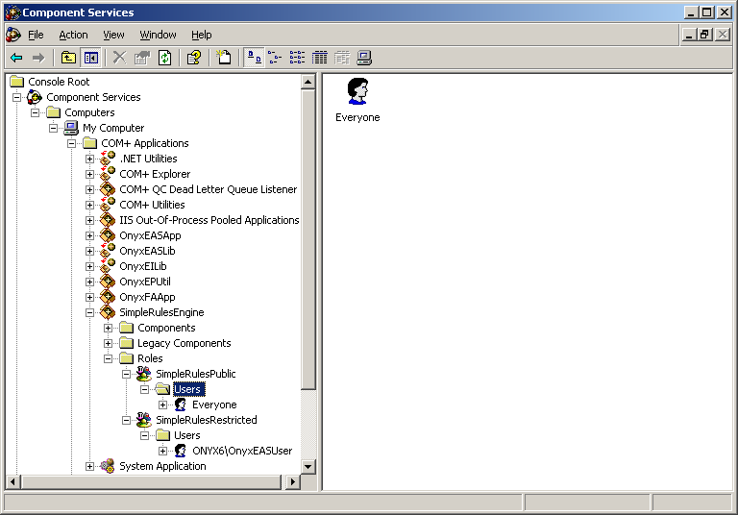

Adding system messages
When using the Onyx SRE adapter, the system messages used by the engine are stored as National Language message strings. To add these message strings, complete the following steps.
- Using SQL 2005 Management Studio, run the scripts in the <install location>\database\Onyx folder to insert National Language category and message values into the Onyx Enterprise Database.

Adding repository configuration
When using the Onyx SRE adapter, the repository details are stored as part of the Onyx logical application configuration.
- Copy the <install location>\configuration\simpleRules folder to the folder containing the Onyx Enterprise Dictionary for your logical application (eg. “c:\program files\Onyx\AppServer\Applications\Onyx” is the typical location for the Onyx logical application).
When using the web services SRE interface:
- Copy the <install location>\configuration\simpleRules folder to a suitable location for your rules repository, then edit the <install location>\engine\runtime\simpleRules.repositories.xml to point a named repository to this location.

Setup the Web Service
Note: these steps are only required when using the web services SRE interface.

- Open the <install location>\WebService\web.config file. Edit the location of the simpleRulesEngine.dll codebase by changing the following line:
<codeBase version="1.2.0.0" href="file://$install location$\Engine\Runtime\Release\extIT.SimpleRulesEngine.dll" />
Replace $Install Location$ with the location of the install directory.
- Open the Windows Internet Information Services (IIS) Manager administration tool.
- Add a new virtual directory for the Simple Rules Engine web service.
Set the alias to a suitable name for the your service (eg. "simpleRulesEngine").
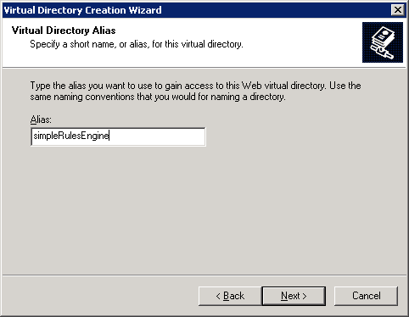
Set the content directory to the <install location>\WebService directory.
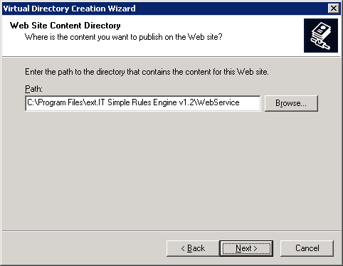
Allow permissions to Read and Run scripts and finish the Virtual Directory Creation Wizard.
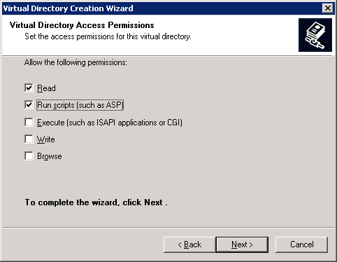
- Open the Properties dialog for the virtual directory that was created.
- In the ASP.Net tab, set the ASP.Net version to 2.0.x (to use the .Net Framework 2.0).
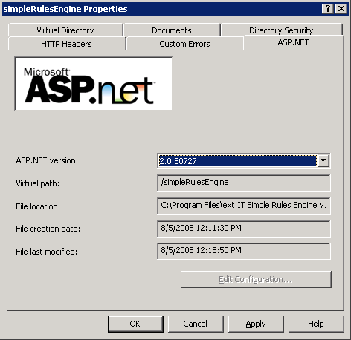

Need more information?
For more information, contact ext.IT:
Email: info.us@ext-it.com
Phone (US): +1 206.375.8695
Phone (Australia): +61 2 8006 2206

